

LAB EXPERIMENT RECORD
SET 16

Department | Artificial Intelligence and Data Science
Course Code / Course Name | DSA0601 / Data Handling and Visualization
Name / Register Number | ROHAN P T / 192424112
Date / Day | 10/10/2026

Aim
To analyze customer demographics analysis using the requested visualizations and dashboard views.

Dataset
Customer Demographics Analysis
Customer_ID | Age | Gender | Income
1 | 28 | Female | 50000
2 | 35 | Male | 60000
3 | 42 | Female | 75000

R Data Setup
Run this setup once before the R programs below. The dataset is defined inline so each record can be copied and run without a separate CSV file.
R data setup
dat <- data.frame(
Customer_ID = c(1, 2, 3),
Age = c(28, 35, 42),
Gender = c("Female", "Male", "Female"),
Income = c(50000, 60000, 75000)
)

PROGRAM 1: Customer Age Bar Chart
Create a bar chart showing customer ages with labeled axes and title.
R code
barplot(dat$Age, names.arg=dat$Customer_ID, col="skyblue3", xlab="Customer ID", ylab="Age (years)", main="Customer Ages")

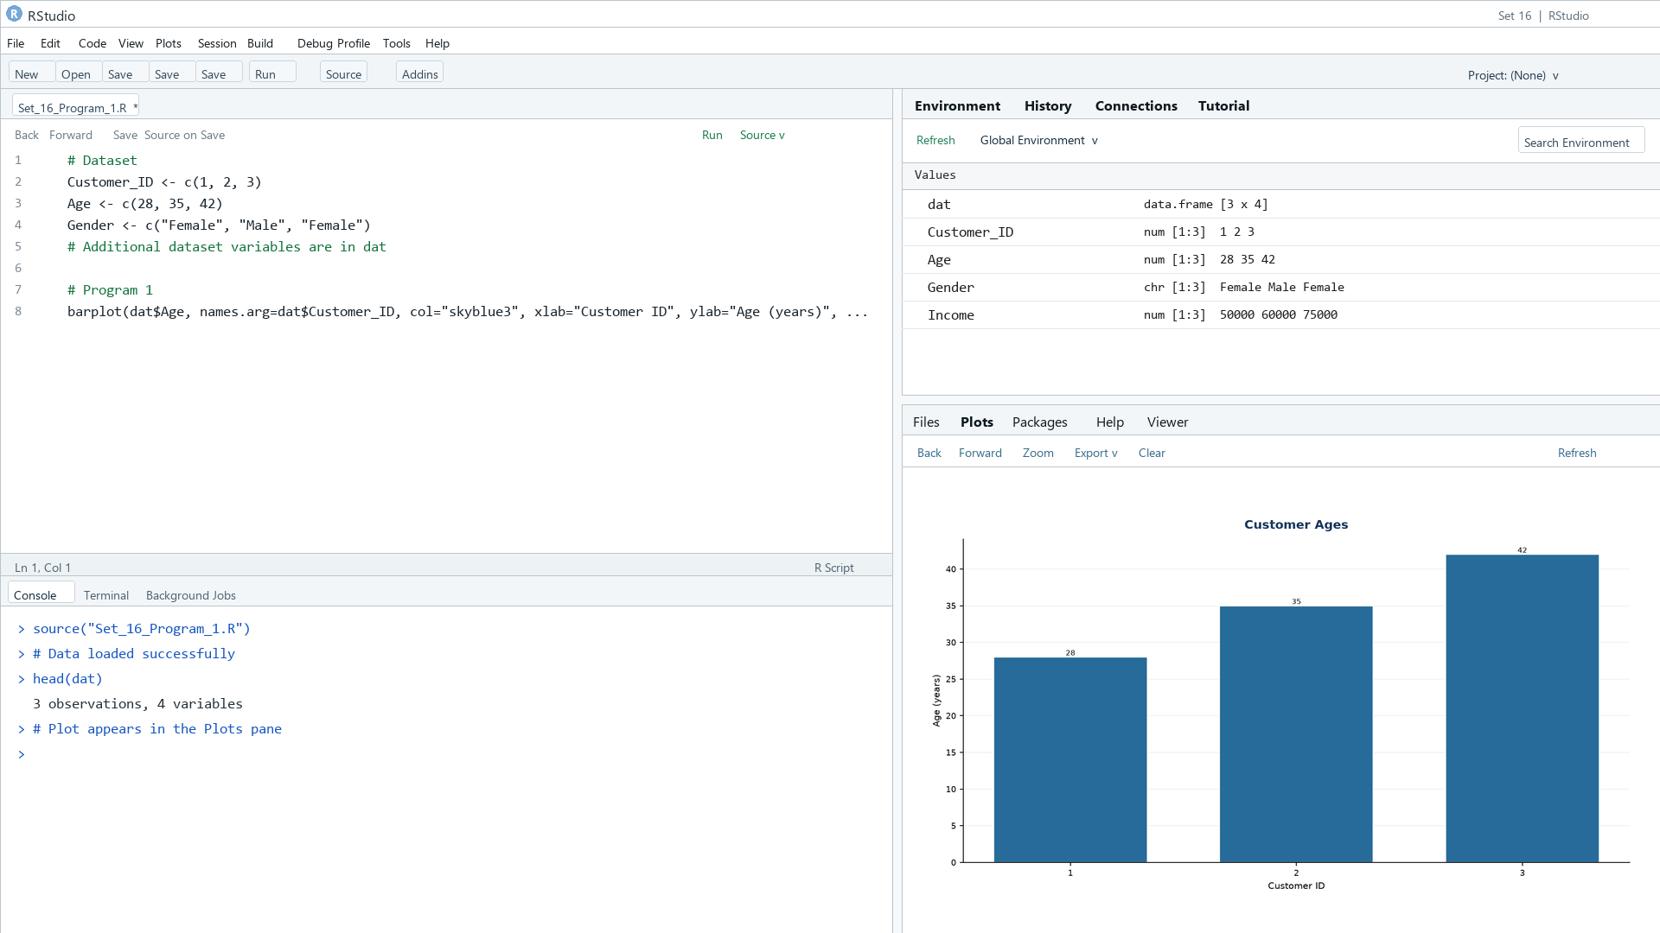
Output 1: Customer Age Bar Chart

Observation: The three customers are 28, 35, and 42 years old.

PROGRAM 2: Customer Gender Pie Chart
Create a pie chart showing the customer distribution by gender.
R code
pie(table(dat$Gender), main="Customers by Gender", col=rainbow(length(unique(dat$Gender))))

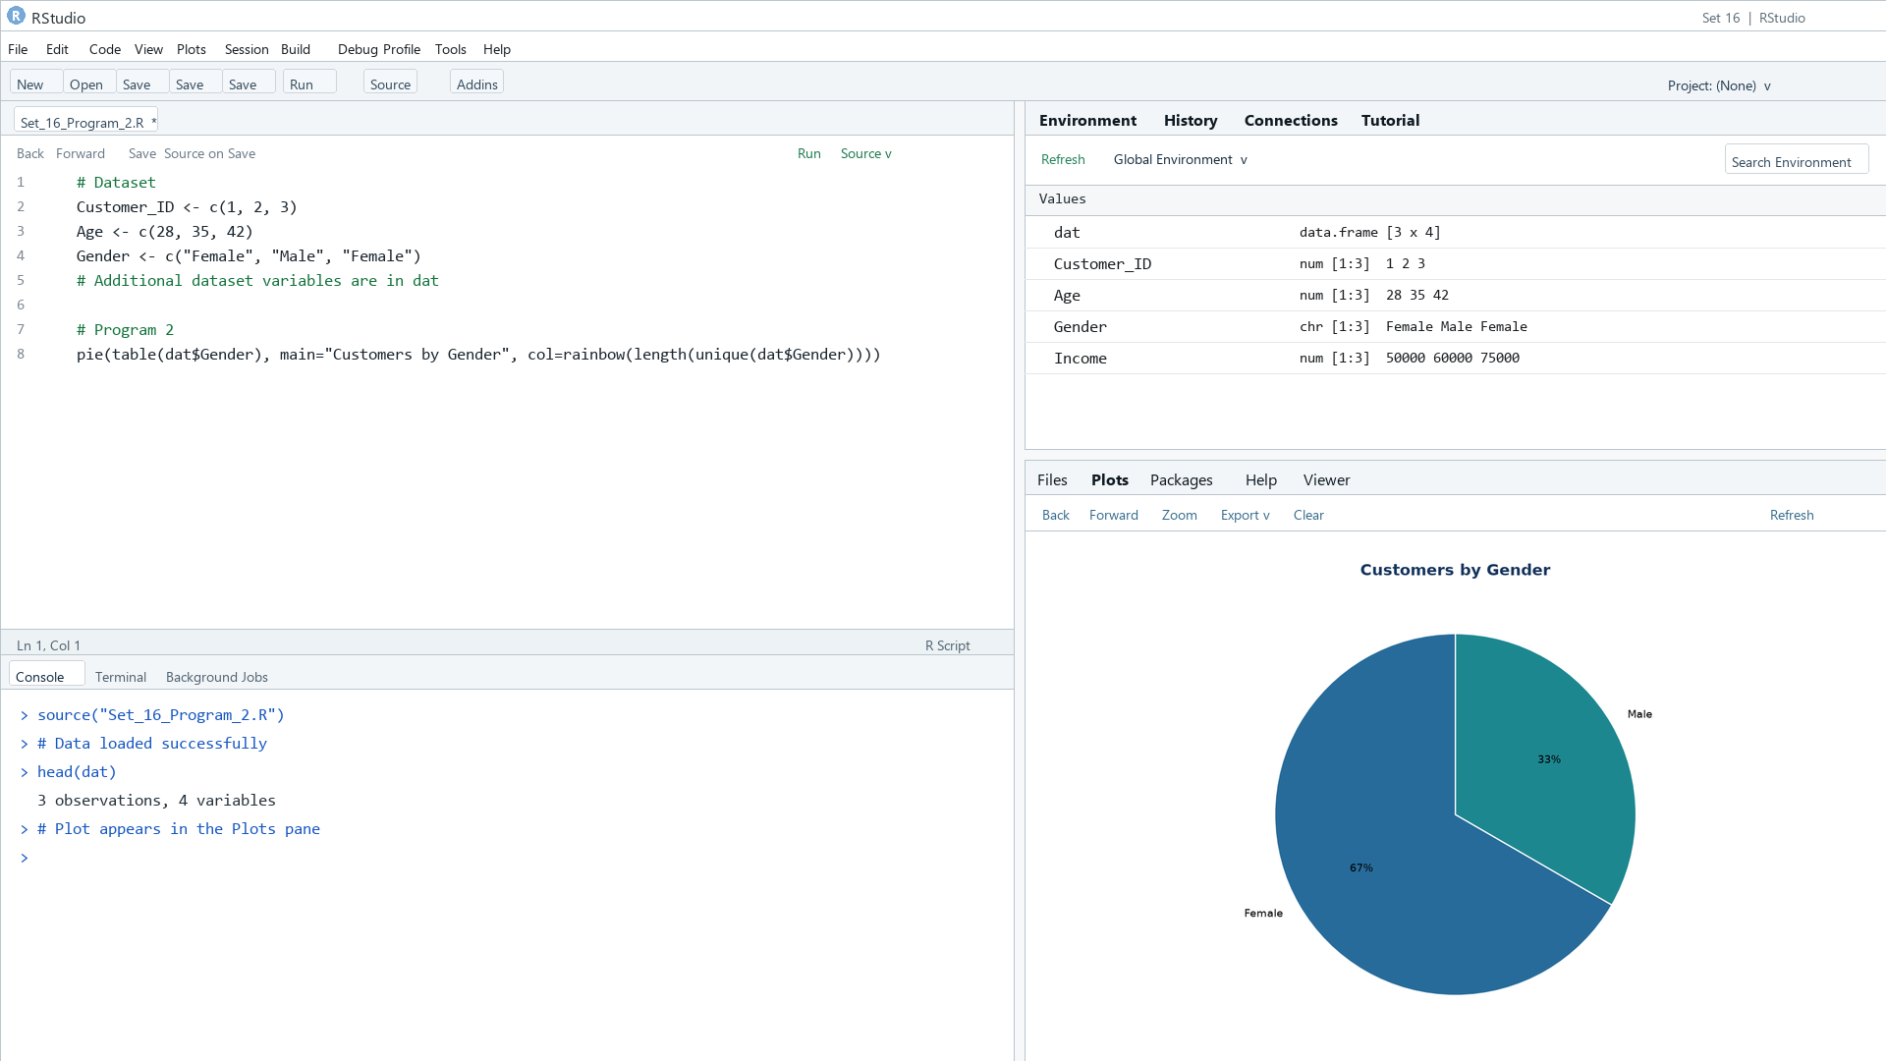
Output 2: Customer Gender Pie Chart
Observation: Two customers are female and one is male.

PROGRAM 3: Customer Demographics Table
Display each customer's demographic information in a labeled table.
R code
print(dat)

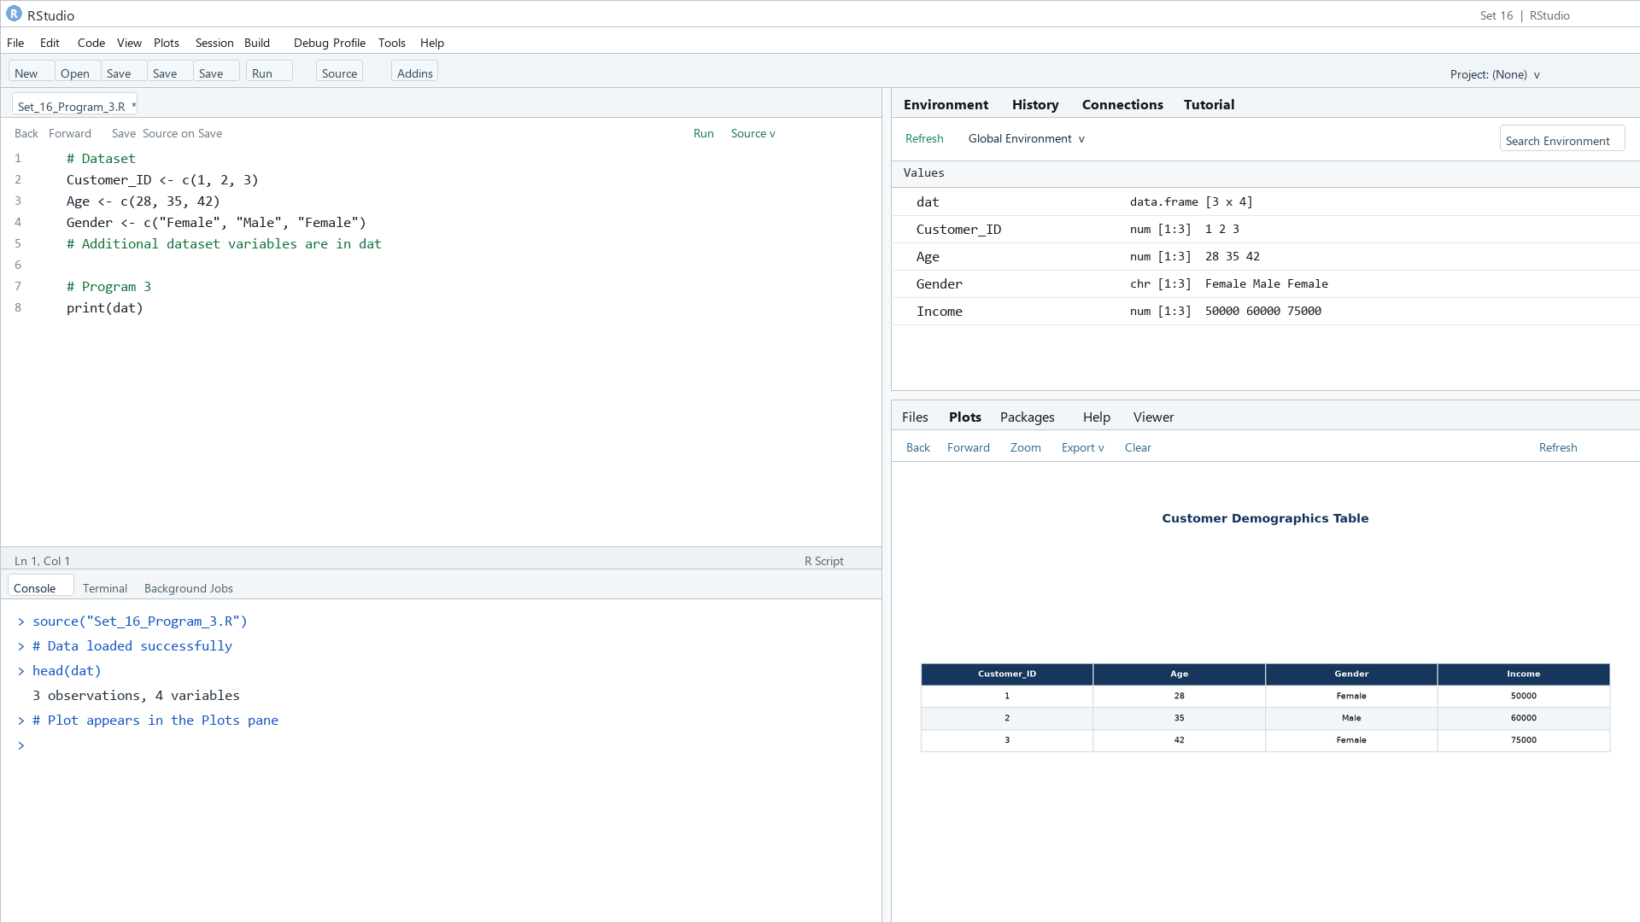
Output 3: Customer Demographics Table
Observation: The table includes age, gender, and income for all three supplied customers.

PROGRAM 4: Customer Demographics Dashboard
Create a Tableau dashboard combining the age chart, gender pie chart, and demographic table.
Tableau build steps
Tableau dashboard build
1. Connect to the customer demographics table.
2. Create an age bar chart by Customer_ID and a gender pie chart.
3. Create a text table with Customer_ID, Age, Gender, and Income.
4. Arrange all three sheets on a dashboard and add a Gender filter.

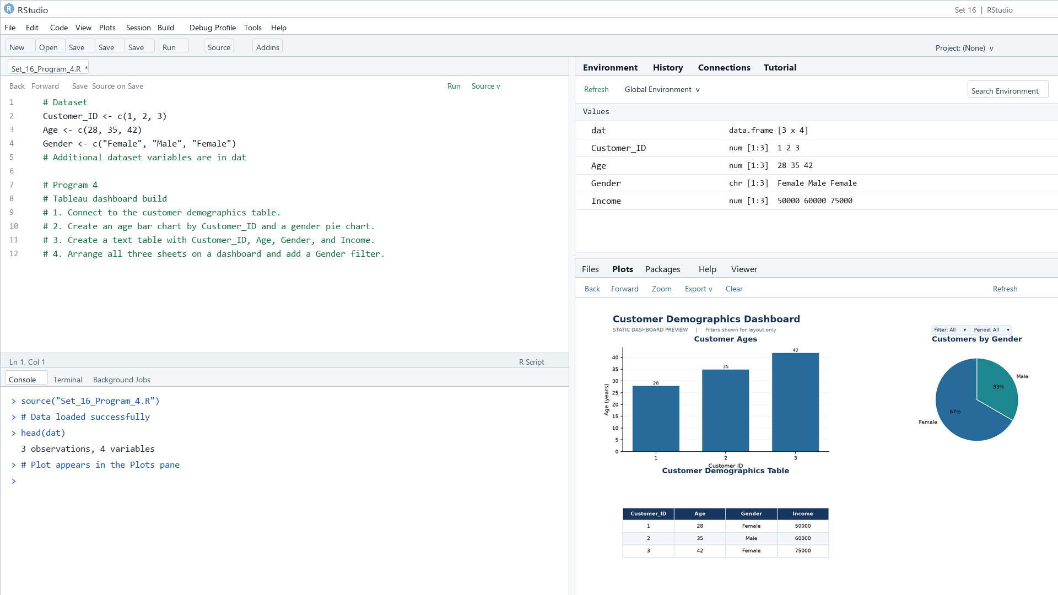
Output 4: Customer Demographics Dashboard

Observation: The preview places the age, gender, and customer detail views together for coordinated exploration.

Procedure
1. Review the dataset table and confirm any illustrative fields noted in the record.
2. Run the R setup block once, then run the requested program code.
3. Compare the output screenshot with the observation and replace illustrative values when actual data is available.
4. For Tableau tasks, connect to the displayed data and follow the dashboard build steps.

Result
The requested charts and dashboard views for Set 16 were prepared from the displayed dataset. Outputs include labels, short observations, and code or dashboard construction steps.

Key Functions Used
plot(), barplot(), hist(), boxplot(), table().

